James Donahue

Computer Science 430

Dr. Karen Anewalt

24 March 2019

Group Maker Usability Study

**1. Overview of System Functionality**

This system is a simple program which will create groups of students for group projects. The client is Dr. Karen Anewalt, a professor of Computer Science at UMW. The program will ask the user to input a csv file containing a list of students in the class, ask the user what criteria they would like the groups to be created by and how many students should be in a group, and then sort the students into groups based on the chosen options, outputting the results into a csv file. I am assuming that the user has at least basic knowledge of how to use a computer, and can learn to use new software, whether GUI or CLI, with minimal training.

**2. Imaginary Users**

a. Dr. Stefan Davis is a professor of Computer Science. He is a self-described “power user,” and this is shown by the fact that he likes to use the mouse as little as possible. He is a skilled Vim user, and instead of a standard desktop, he uses a tiling window manager. For the few graphical programs which he needs to use, he has memorized all the keyboard macros. He greatly prefers programs which can be run from the command line, or at least provide all the main functionality through use of the keyboard.

b. Dr. Smith is a professor of Computer Science. She has used Macs primarily throughout her career, so she is more comfortable with graphical software. She almost exclusively uses software with well-designed GUIs. She is knowledgable of the command line, but prefers using a mouse for most tasks.

c. Dr. Kelly is a professor of Biology. He has only used Windows computers in his life, and has little experience with command line interfaces. He does not have any extensive knowledge of computers, and knows no common keyboard shortcuts except Ctrl-C and Ctrl-V. A well-designed, intuitive GUI is an essential feature for any software he uses, though he could potentially learn to use a simple text-based program.

**3. User Model**

a. I am creating software for Dr. Anewalt of the Computer Science department. This software will create groups from a list of students. Group generation could be completely random, or it could take certain criteria into account. The user will also be able to edit the groups before saving them.

b. Focus group feedback:

Person 1: Simple interface, checkboxes for attributes

Person 2: Drop down list for picking group size, generate button, list of students on side, show boxes with all created groups, highlight student to show exclusions

Person 3: Sidebar with student info, input for group size and number of groups

Summary: The program should have a simple UI. It should show the list of students in a side pane, have checkboxes or drop-down lists for selecting attributes, and have a clearly-labeled button to generate the groups.

c. User Model

All surveyed people say that the user interface should be simple. There should be a pane that shows the list of students in the class, checkboxes to allow for selecting options for creating the groups, and a button to press that creates the groups.

**4. Prototype Image**

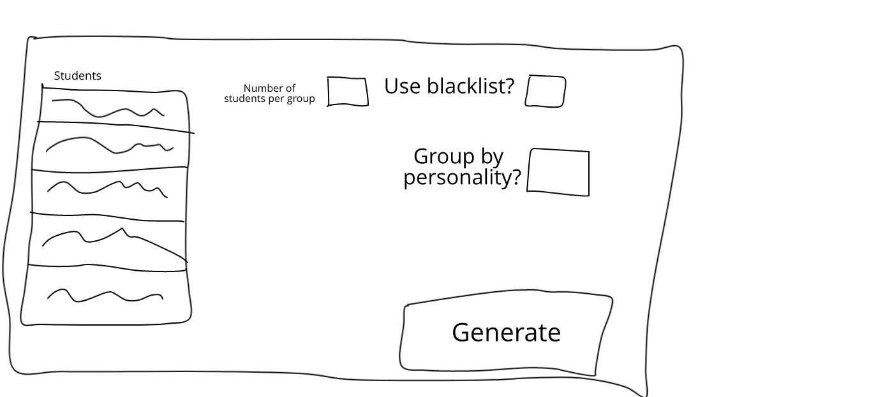

**5. Focus Group Feedback**

a. Comments on prototype images

Person 1: What I expected to see given the explanation

Person 2: Simple, easy-to-use

b. Reflection on feedback:

All those who saw the prototype UI agreed that the UI was simple and what they would expect from a program such as this

**6. Changes**

Based on the feedback I received, I don’t plan to make many changes to the user interface. I will add checkboxes to allow the user to make groups based on different options, as my prototype only had a couple of options available, but other than that I will keep my interface the same as what I showed.